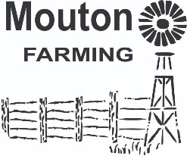**Schaaprust Lodge and Self-catering**

**Email:moutonfamilyfarm@gmail.com**

**BOOKING POLICIES AND PROCEDURES**

**Provisional Booking Policy**

◊ Provisional bookings will be held for 14 days and will be automatically released where no written confirmation or cancellation is received.

◊ Provisional bookings made within the cancellation period will be subject to its conditions and payment will be required accordingly.

**Payment Policy**

◊ We will require 100% accommodation deposit to confirm your provisional booking

◊ Proof of payment must be emailed to us and must include your booking reference (surname and date)

◊ All rates and conditions are subject to change Cancellation Policy

◊ In the event of a confirmed booking not being cancelled or amended in writing, the following cancellation policy will apply:

30 - 23 days prior to arrival - 50% 22 - 15 days prior to arrival - 80% 14 - 8 days prior to arrival - 90% 7 - 0 days prior to arrival - 100%

**Children Policy**

◊ Free of charge Children of 0 to 6 years of age

◊ 50% Children of 7 to 14 years of age

◊ Full rate Children of 15 years of age and older

◊ Only one child may share a room with the parents